AWS Assignment

Step 1: Created a VPC and created 2 subnets inside it.

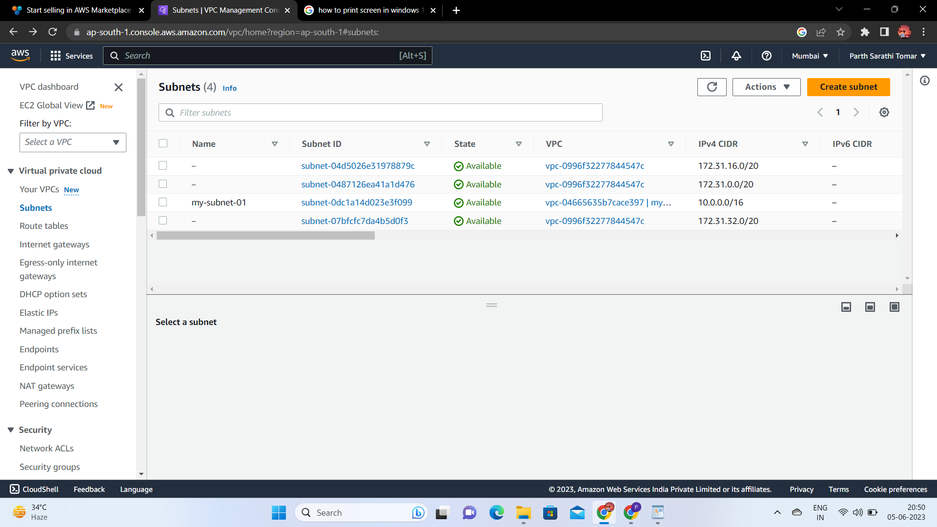

Step 2: Inside one of the subnets, create a VM and deploy an application code inside it

Deploy the same application to Elastic beanstalk Service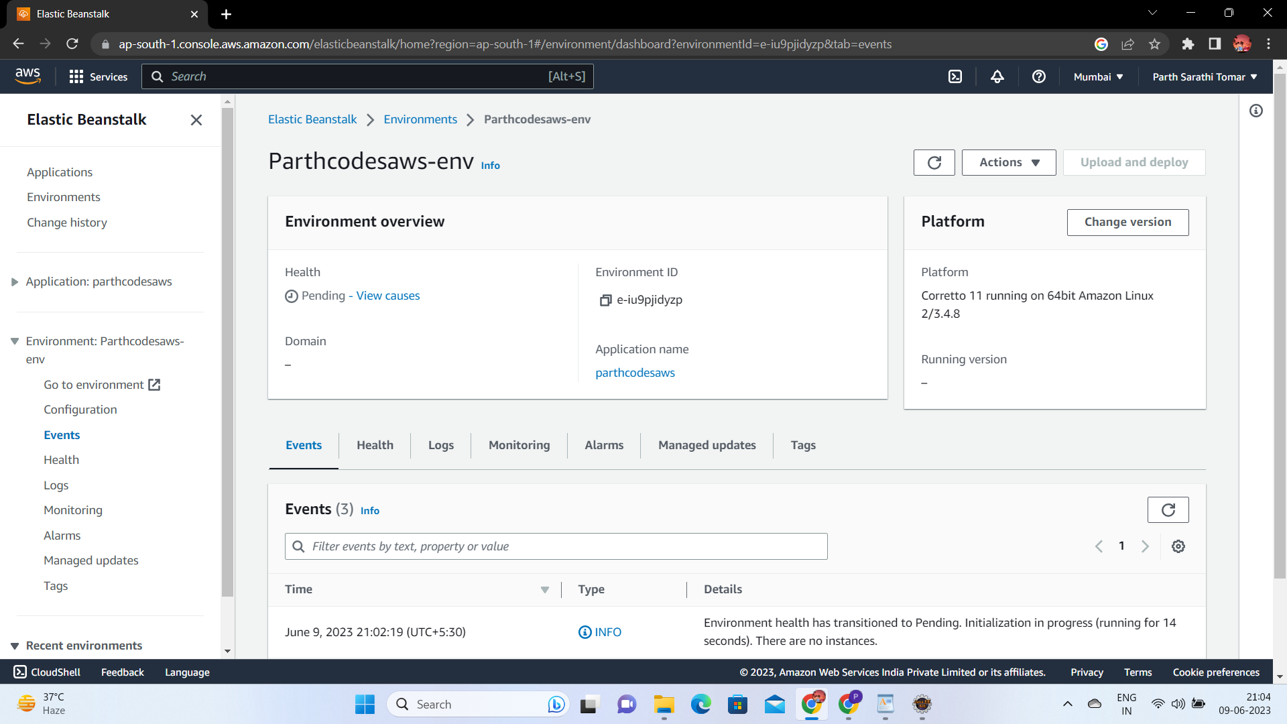

Step 4 Create a Lambda that should trigger as soon as you upload a file in the S3 bucket.

Function should be able to print the name of the file uploaded in the function.

